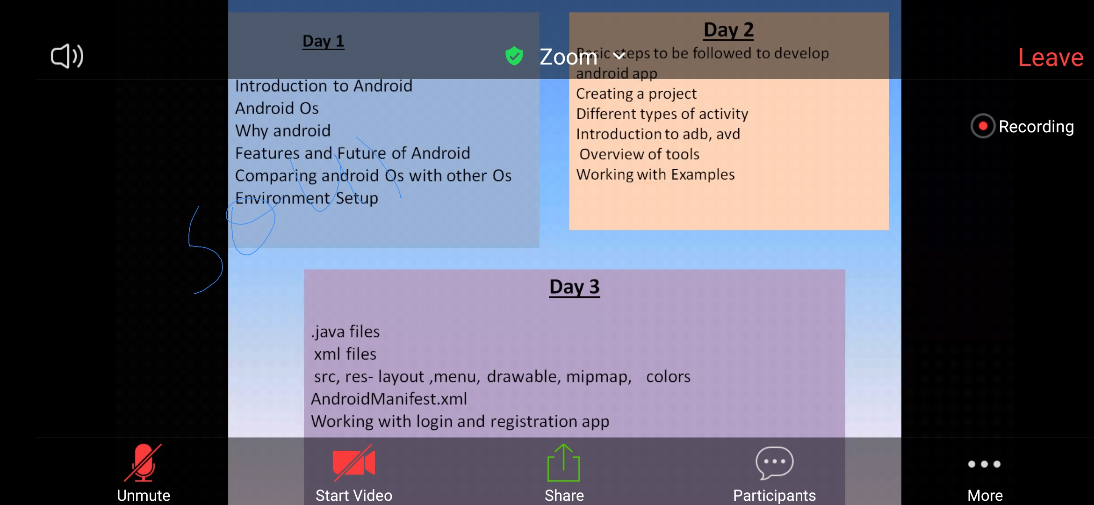

* now Android is not only on mobile , but also tv , washing machine etc..
* come in 2003 , Google owned it in 2005 with 240 million rs.

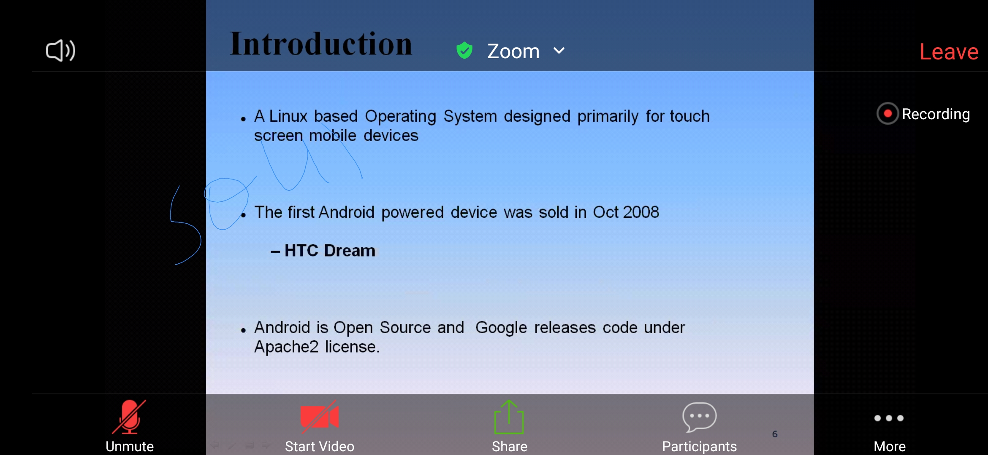

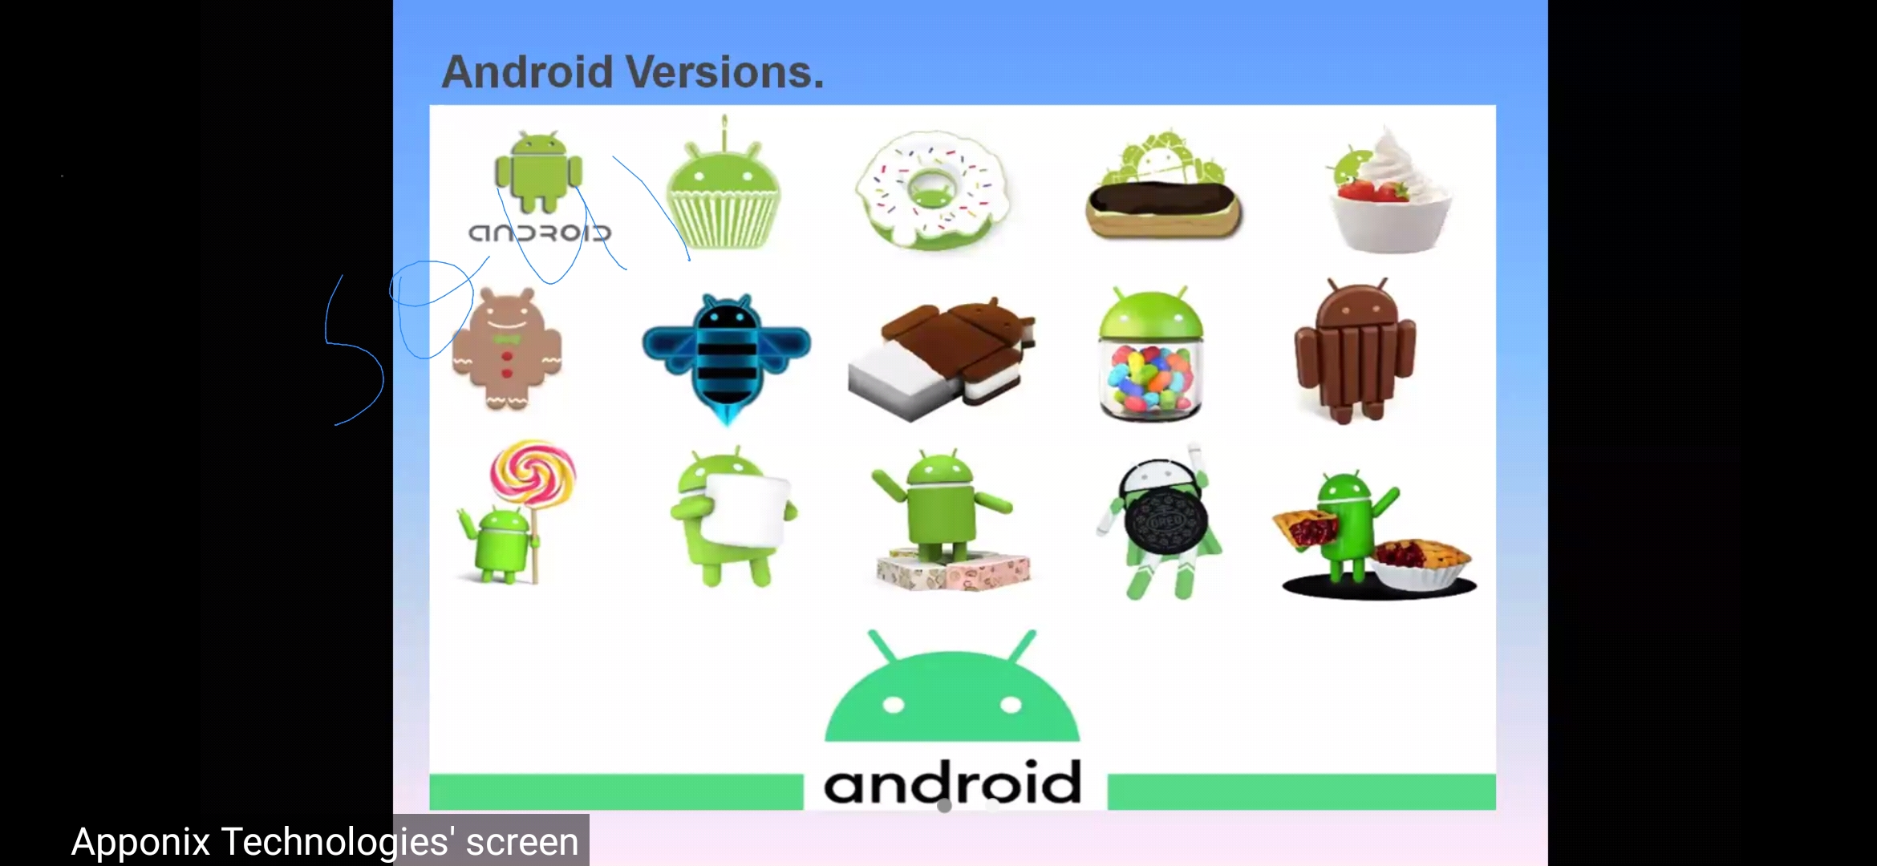

?Open Hansett Comsertium ..?- first manages Android

Latest version is R version..

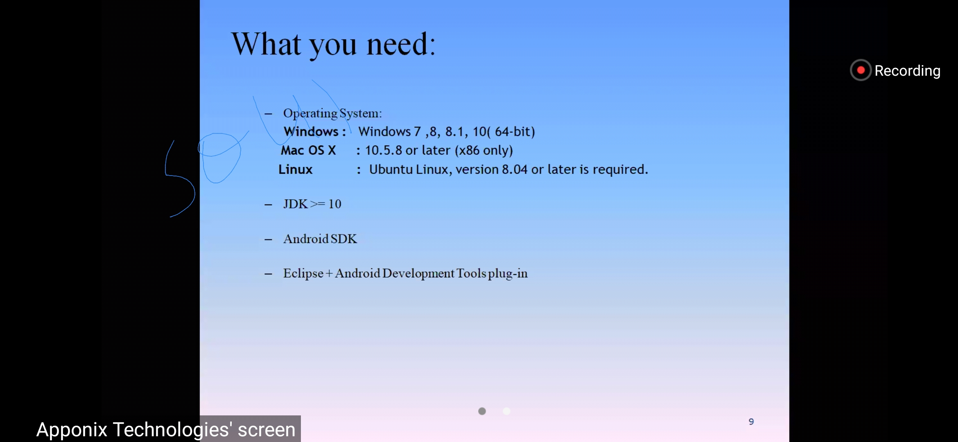

* new features in new versions like face recognition , eye recognition etc..
* Android studio ( have multiple features) or eclipse
* SDK - Software Development Kit ..
* Android studio not work on 32bit OS

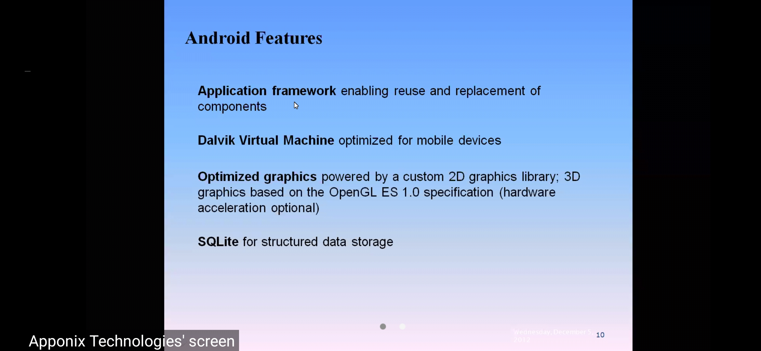

* kotlin , java , c ,cpp - can code for Android

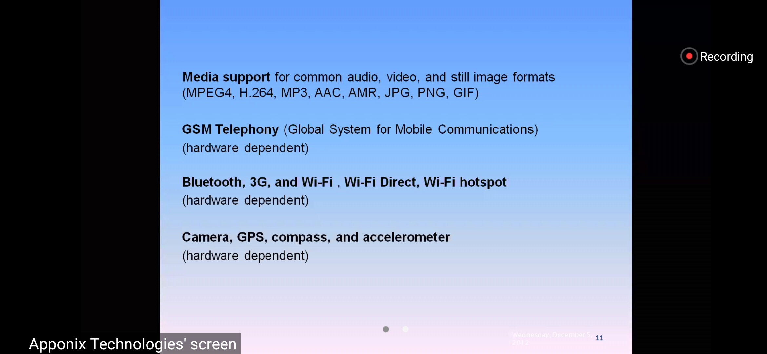

Why Android :

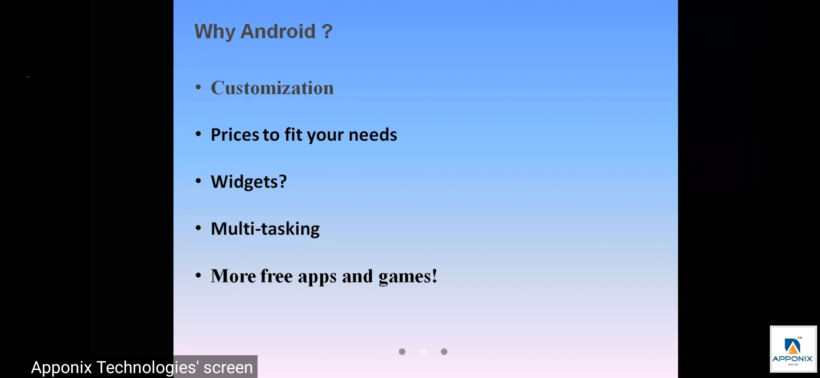

* other mobile Os - symbian , ios , blackberry
* to deploy app on playsotre - $25 dollars for lifetime with your playsotre account …when more download , Google will pay you money ..

Market share of Android :

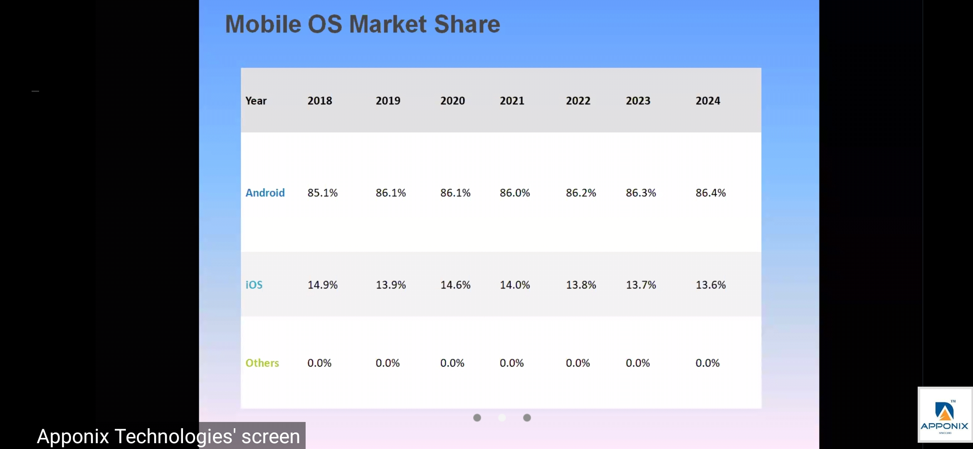

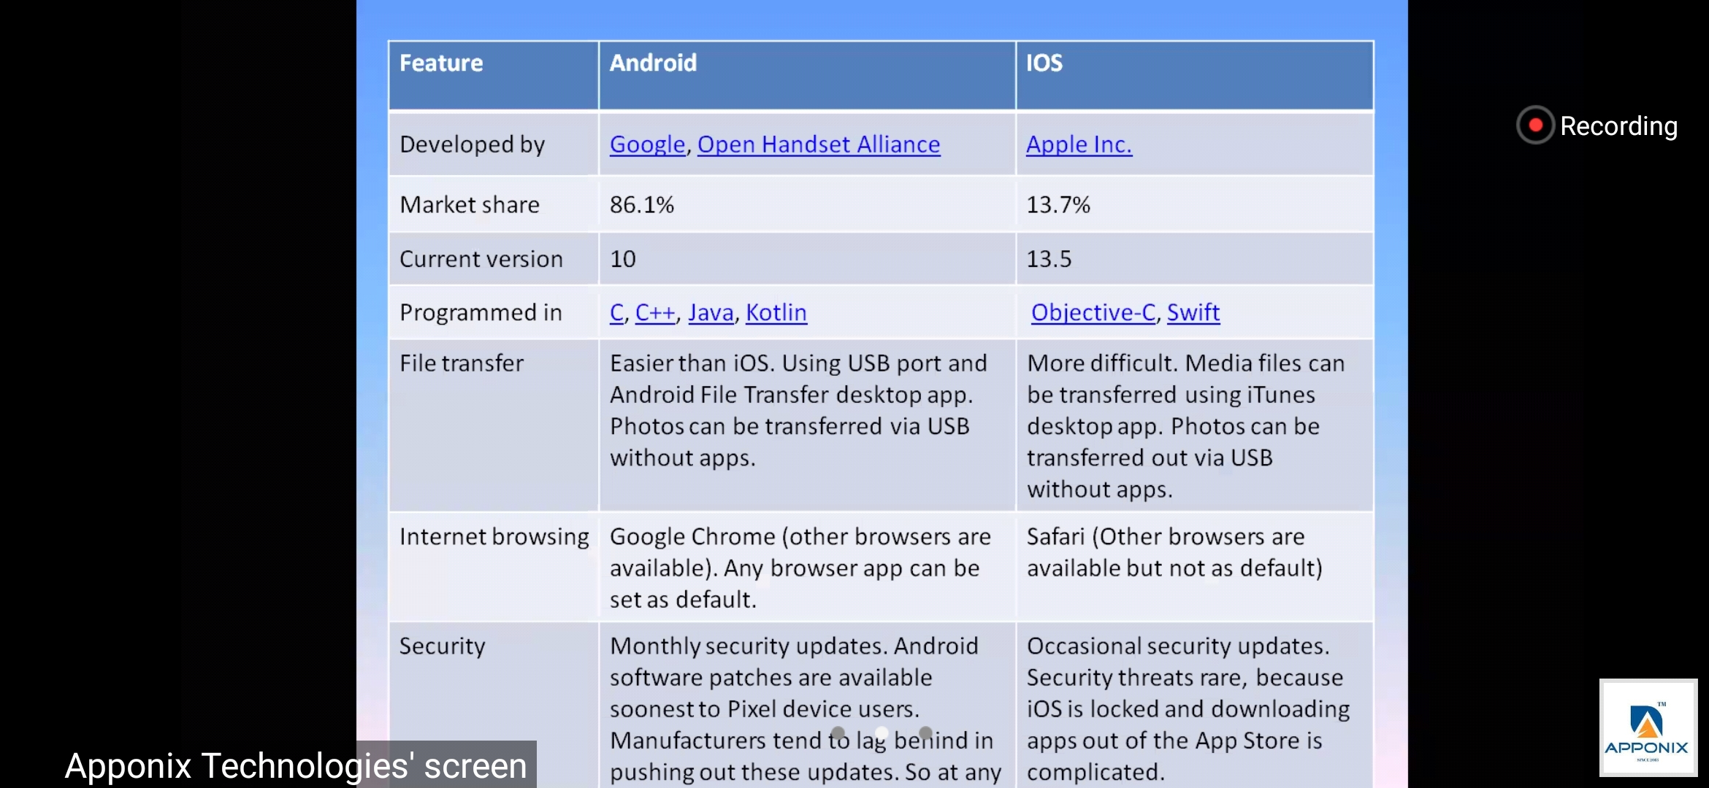

* you cannot use SDK for Development in cpp, c .. they differs ..
* Android is modified version of linux ( foremly called unix )

Architecture of Android :

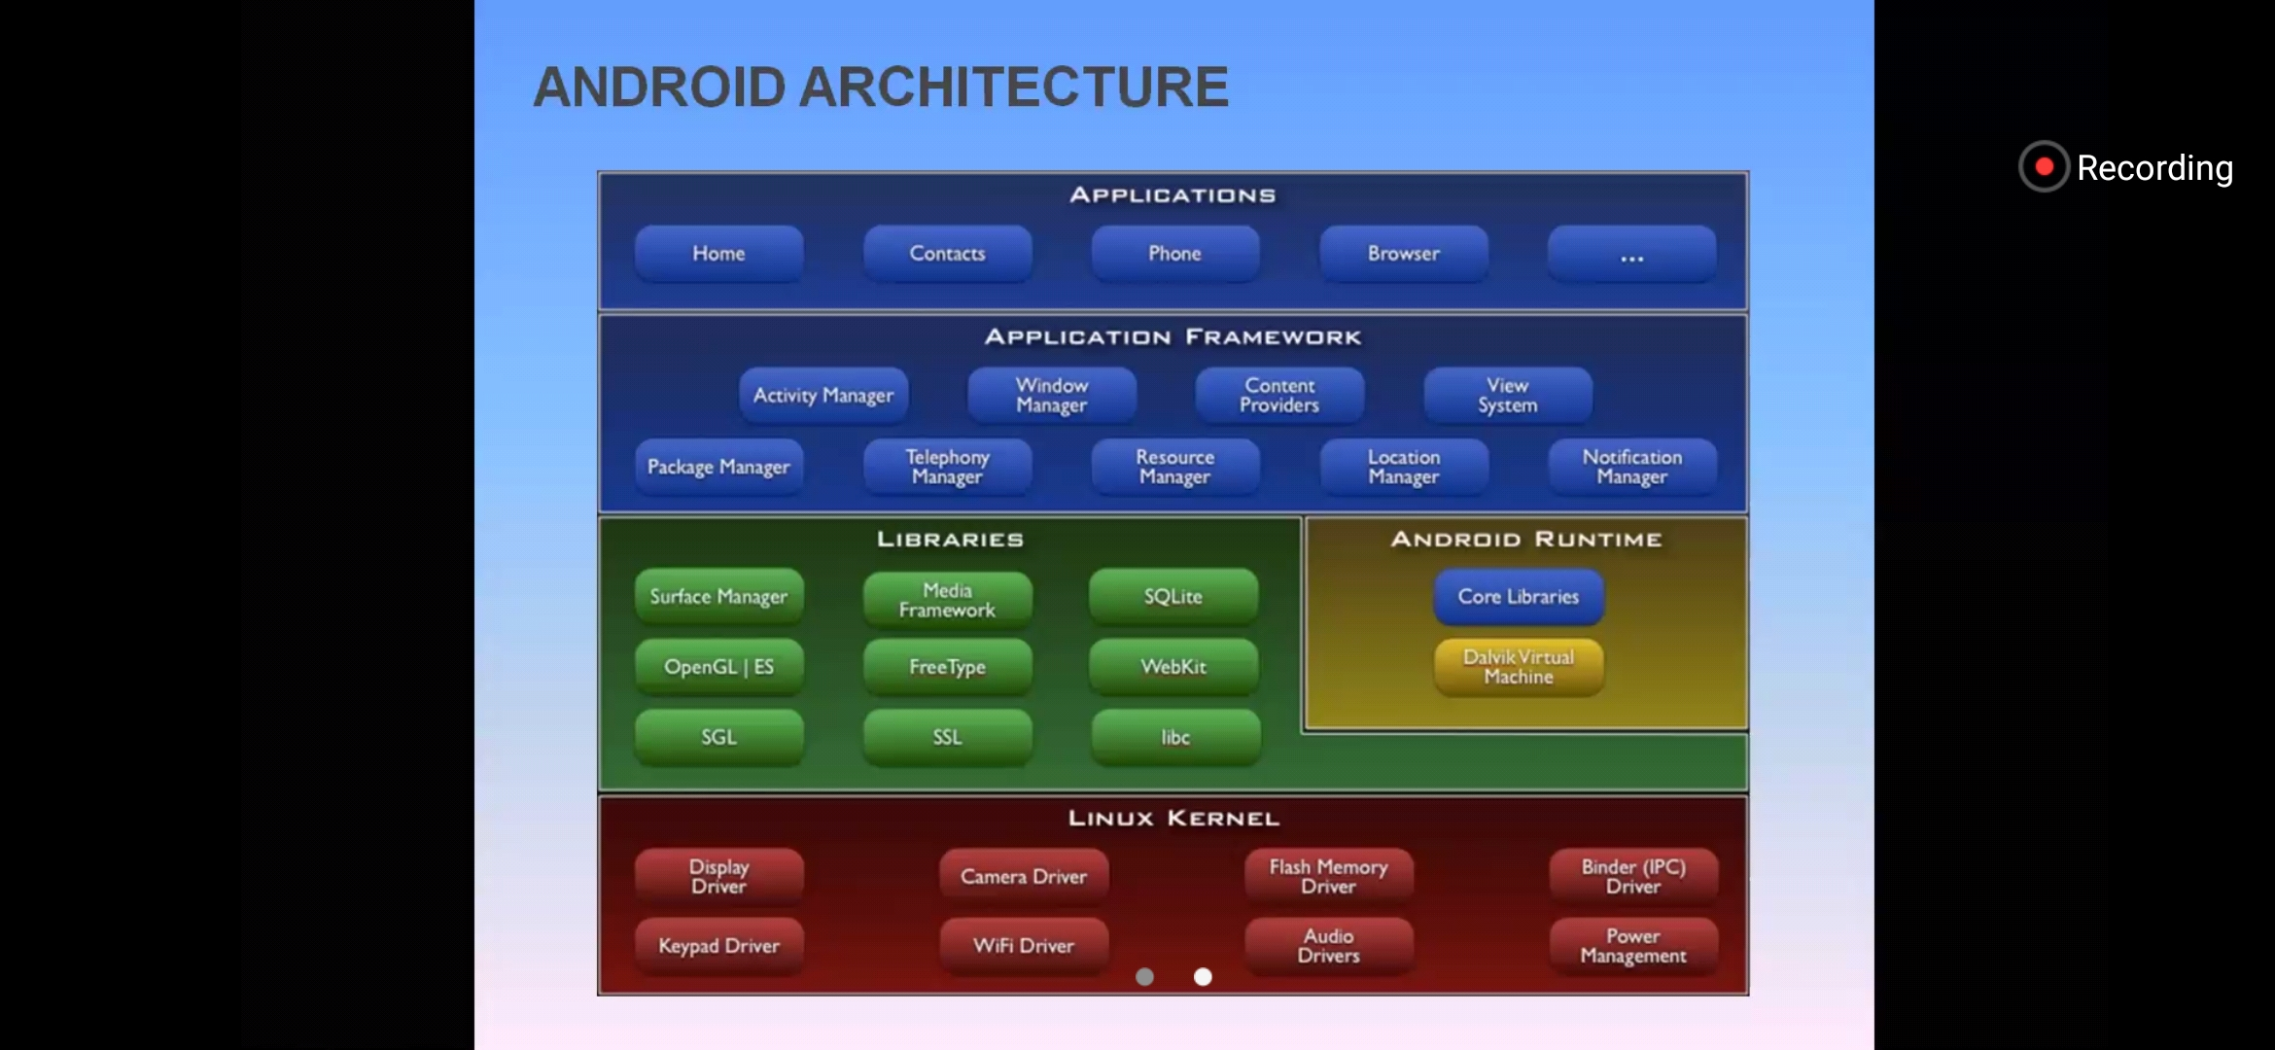

Android = kernal + middle ware [ Android development kit ] (lib, runtime, frameworks) + apps

middle ware - written in c,cpp ( lib & run time) & java( for framework )

Linux kernel - past of OS which has multiple drivers

Android runtime - after conversion of source code to machine , it runs on Virtual machines - JVM & DalvicVM

Libraries - many manylibries like webkit for browsers etc...

* to use python for Android , use python frameworks ..

now Android is available in many devices [ tv , micro oven , etc ] .. because of rich community ..

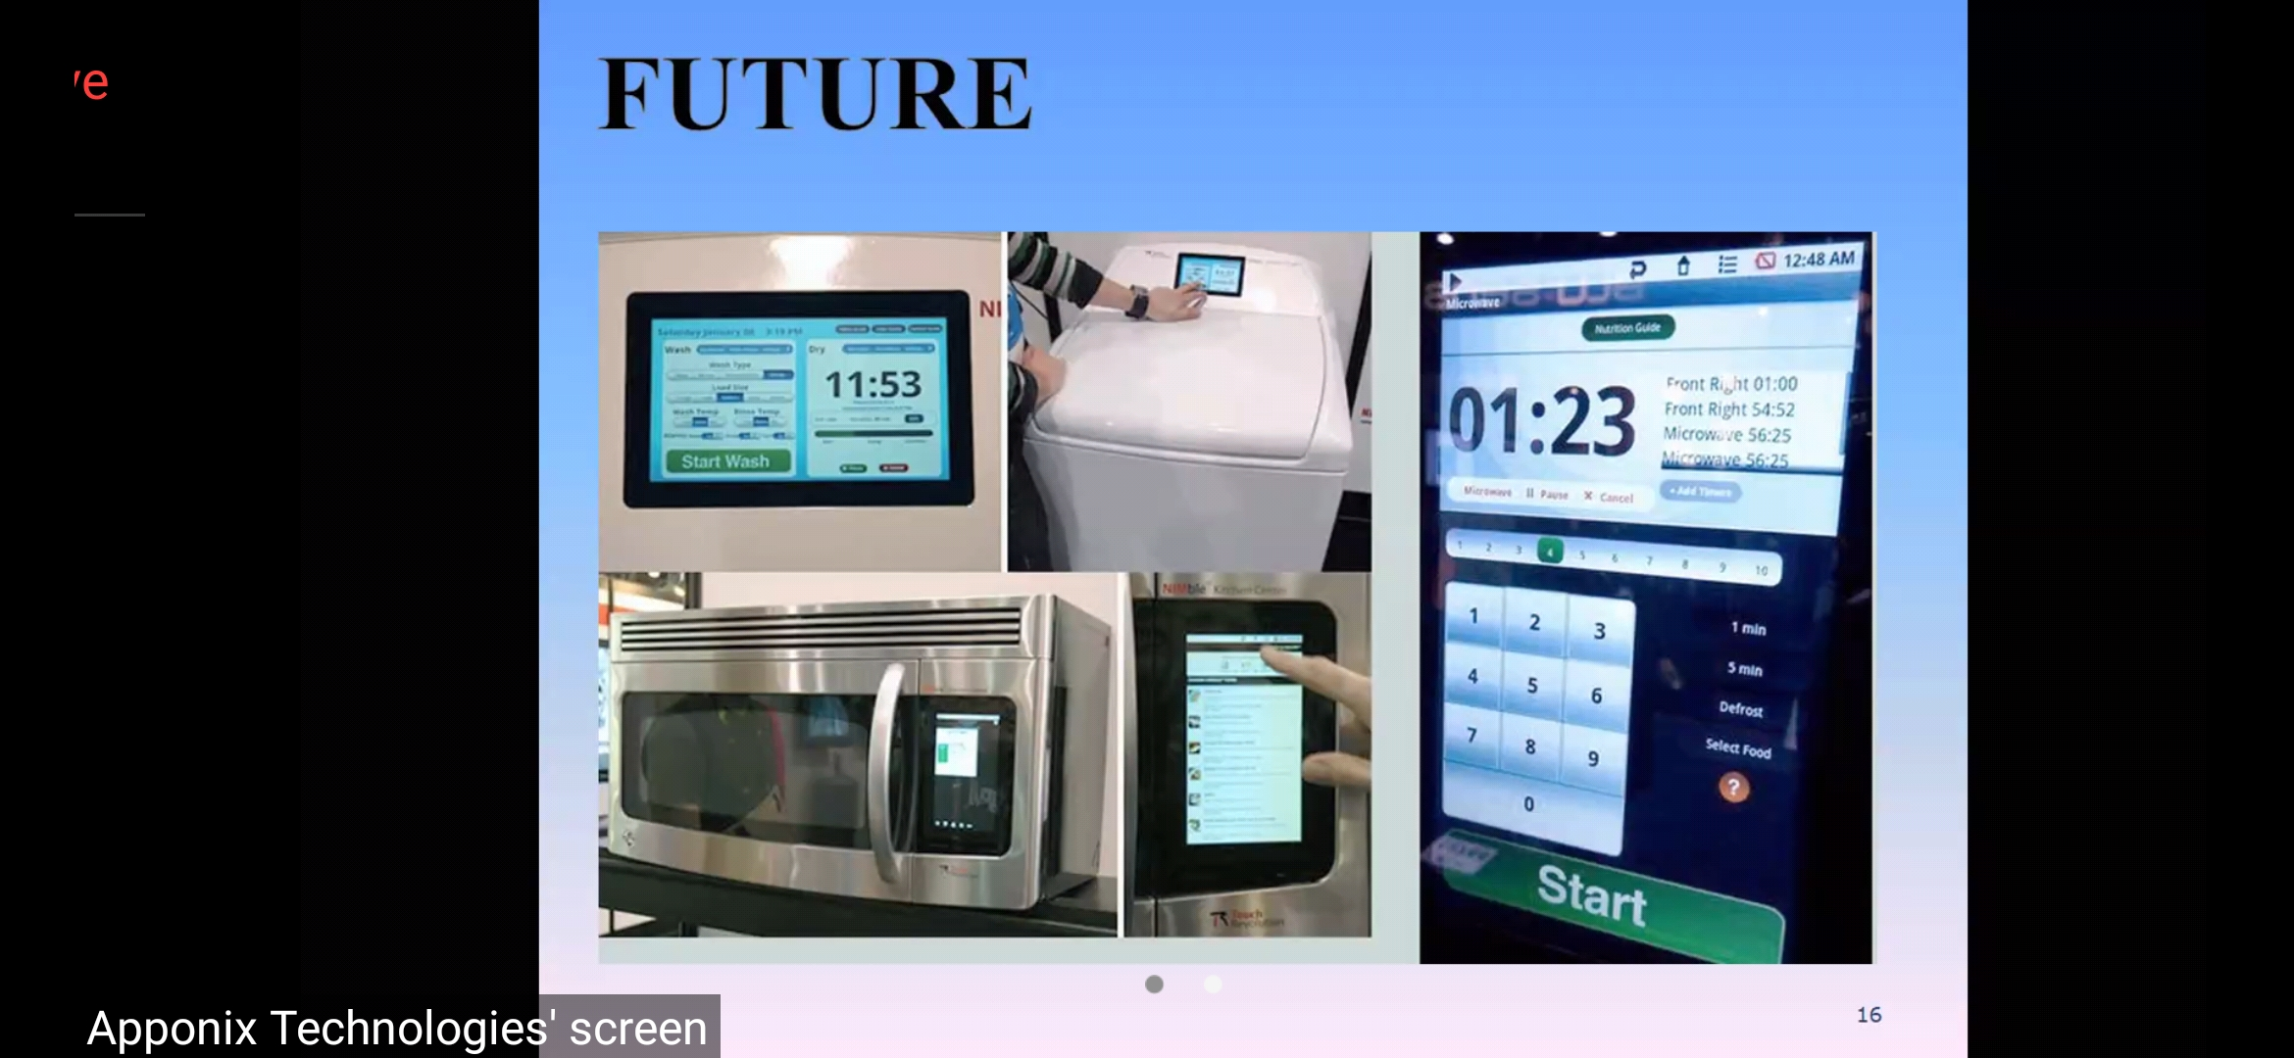

* can install Android studio at developer.android com/studio ..

<https://developer.android.com/studio>

* plugins & repositories needed for installation , so internet must be ON..